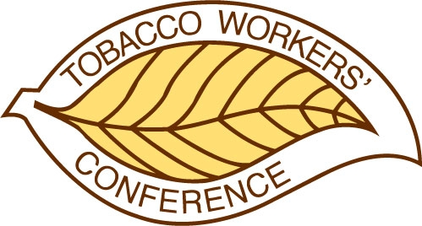
TOBACCO WORKERS’ CONFERENCE

25-year Recognition Request

To receive a recognition certificate, workers should have been associated with the Tobacco Workers’ Conference for 25 years or more. Self-requests are permissible.

All forms must be submitted by email to info@twconference.com by December 31, 2025, to be included in the official program. Recognition and certificate awards will be presented during the luncheon on Thursday.

Nominee

Name: Length of Service:

Organization and/ or affiliation:

Title and/or professional designations:

Email:

Telephone:

Brief Description of Work:

Nominator

Name:

Email:

Telephone:

