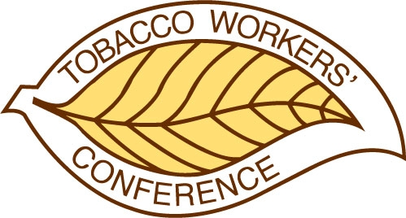
TOBACCO WORKERS’ CONFERENCE
Meeting Request Form

Committee meeting rooms will be available beginning at 9:00 a.m. Monday. To request a room assignment, please complete and submit the form below no later than October 15, 2025. All room assignments will be announced in early December. Forms must be sent to info@twconference.com.

All meeting requests include the following: meeting room, light afternoon break, and specifically requested AV. Rooms will be set as ‘classroom’ unless otherwise requested.

If you need a meeting room on any day other than Monday, please get in touch with info@twcoference.com.

Name of Committee:

Chairperson or Organizer:

Email:

Telephone:

Preferred Time:

Length of Meeting:

Expected Number of Attendees:

AV Requirements:

Comments or requests:

