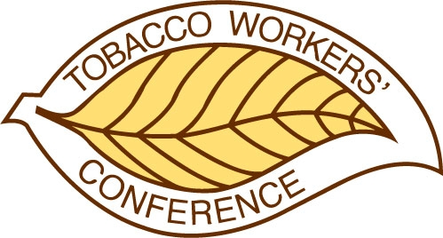
TOBACCO WORKERS’ CONFERENCE

Remembrance Request

If you feel it would be appropriate for the TWC to extend condolences to the family of a person who has passed away since the last conference, please submit the form below to info@twconference.com.

To be included in the official program, all forms must be submitted by December 31, 2025. Condolences will be offered during the luncheon on Thursday.

Remembrance

Name:

Organization and/ or affiliation:

Title and/or professional designations:

Family contact name:

Family contact information (mailing address or email):

Nominator

Name:

Email:

Telephone:

